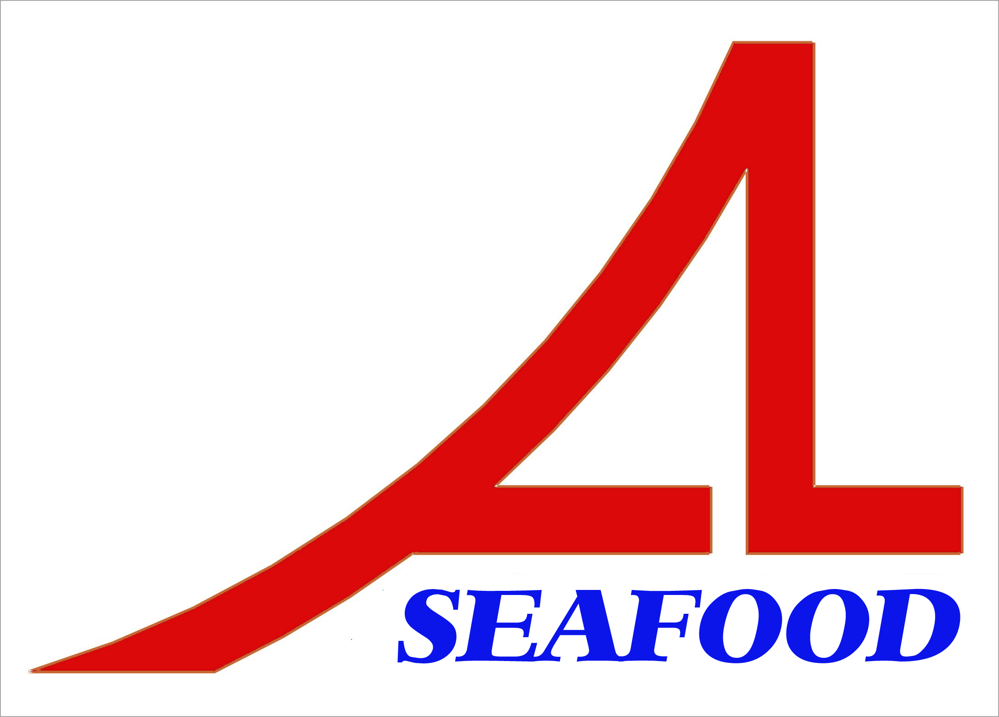AN LAC SEAFOOD CO., LTD.

Lot A14, 4A Street, Hai Son Industrial Zone, Duc Hoa District, Long An Province, Vietnam.
* E-mail: longan@anlacseafoods.com * Website: www.anlacseafoods.com

* Tel : 84-72-3850606 * Fax : 84-72-3850608

OFFER SHEET

Date: May 05, 2018

To: DAE YEONG FOOD CO.,LTD
69 Anneungan-gil Jori-eup Paju-si Gyeonggi-do Korea

We would like to offer you the products by our company with terms and conditions as follows:

1/ GOODS:

No. | DESCRIPTION OF GOODS | SIZE | QUANTITY  (KGS) | CNF INCHON PORT, KOREA  (USD)
 |  |  |  | UNIT PRICE | Amount
01 | DRIED SEASONED LEATHER JACKET | BONE | 4,000 | 4.80 | 19,200
2 | DRIED SEASONED LEATHER JACKET | M | 4,500 | 9.20 | 41,400
3 | DRIED SEASONED LEATHER JACKET | 3L | 1,500 | 9.20 | 13,800
TOTAL |  |  | 10,000 |  | 74,400

Say : US DOLLAR SEVENTY FOUR THOUSAND FOUR HUNDRED ONLY. (CNF INCHON PORT, KOREA)

2/ SHIPMENT :
Shipment : 20 days after receiving LC
Port of loading : HOCHIMINH PORT, VIETNAM
Port of discharge : INCHEON PORT, KOREA

3/ PAYMENT :
By irrevocable L/C at sight into account of the seller’s No.: 101000268614 at VIETNAM PUBLIC JOINT STOCK COMMERCIAL BANK – GIA DINH BRANCH
Address: 495 - 497an Duong Vuong Street, Ward 08, District 06, Hochiminh City, Vietnam.
Swift. WBVNVNVX

BENEFICARY: AN LAC SEAFOOD CO., LTD.

Valid: May 20, 2018

Looking from and to your early reply.

Thanks and best regards

AN LAC SEAFOOD CO., LTD
DIRECTOR

